46th World Bridge Team Championships, Marrakech Aug. 20 – Sep. 2, 2023
Dear Presidents, dear friends
Let me first clarify the dates of the Championships, since there may have been some confusion on the issue. Registration and the Opening Ceremony takes place on August 19th, and play starts on August 20th.
The Format will be the same as in Wuhan 2019, i.e. 8 days of a Round Robin qualification followed by 2 days each of Quarterfinals, Semifinals and Finals in all categories. The Transnationals will start on August 28th and end on September 1st, except for the teams reaching the Finals which will be played on September 2nd. Further information can be found at http://championships.worldbridge.org/marrakech2023 where additional detail will be added when it becomes available.
It is of utmost importance that each Zone reports the results of its Trials, or other form of selecting the countries qualified for participation in the respective categories of the WBTC, as soon as possible. This not only helps our preparations in general but is also important in case a Zone cannot fill its quota in a particular category. Early knowledge of this will facilitate the process of finding substitutes to fill such spots.
Our hosts, the Royal Moroccan Bridge Federation, has engaged the agency KIAM to handle the accommodation requests for all participants. Special rates have been negotiated at hotels from 3 to 5 stars according to the table below. The Hotel Mansour Eddahbi Mövenpick is connected directly with the playing venue. KIAM at this stage can only guarantee those rates for bookings no later than March 31st, but we are negotiating to get an extension of that deadline and will update you as soon as we know.
A selection of hotel rooms at different price categories have been reserved in Marrakech by KIAM for the 46th World Bridge Team Championships. Hotels rated from 3 to 5 stars are available at the following preferential rates for the event (Bed & Breakfast per room, per night), taxes are not included:

Hotels  (Walking distance to the venue) | 3 stars  (700 m) | 4 stars  (150 m) | 5 stars  (900 m ) | 5 stars Hotel Mövenpick  (at the Venue)
Single room | 70,00 € | 135,00 € | 170,00 € | 190,00 €
Double room | 80,00 € | 135,00 € | 190,00 € | 190,00 €
Optional Meal cost | 20,00 € | 20,00 € | 25,00 € | 35,00 €
City tax per person, per day | 1,6 € | 1,6 € | 2,8 € | 2,8 €

Participants are advised to make their reservation as early as possible to have the best choice of available rooms. Hotel accommodation is subject to availability and will be allocated on a first come, first served basis. The agency KIAM guarantees that current pricing will remain in effect until 31 March 2023.
All the hotel reservations must be done through:
Welcome KIAM SARL
Email: basma.mbarech@kiam.ma Phone: +212 625 99 14 00
Mr. Basma M’Barech, Project Manager at KIAM, is available for any further information.
Best regards
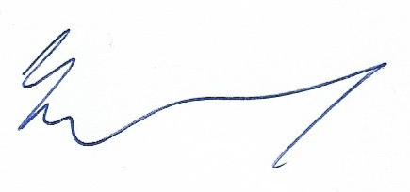
Jan Kamras

